Celect Plus chip programming

- Clean chips

- Get ECM serial number

- Convert number to HEX with 6 digits
  - example s/n 512221 in hex is 7D0DD

  - Check what part number you need

  - Find folder to your correct partnumber ex: 6662 , 8300 ,8303

  - Program serial number on XICOR X28C64
    - at hex address shown below with AA AA AA place holders
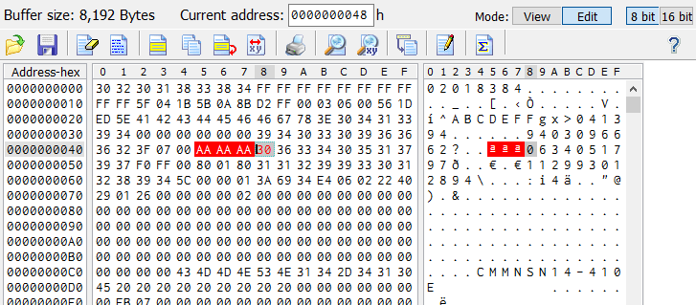

  - Blank the other two flashes ex: AN28F512
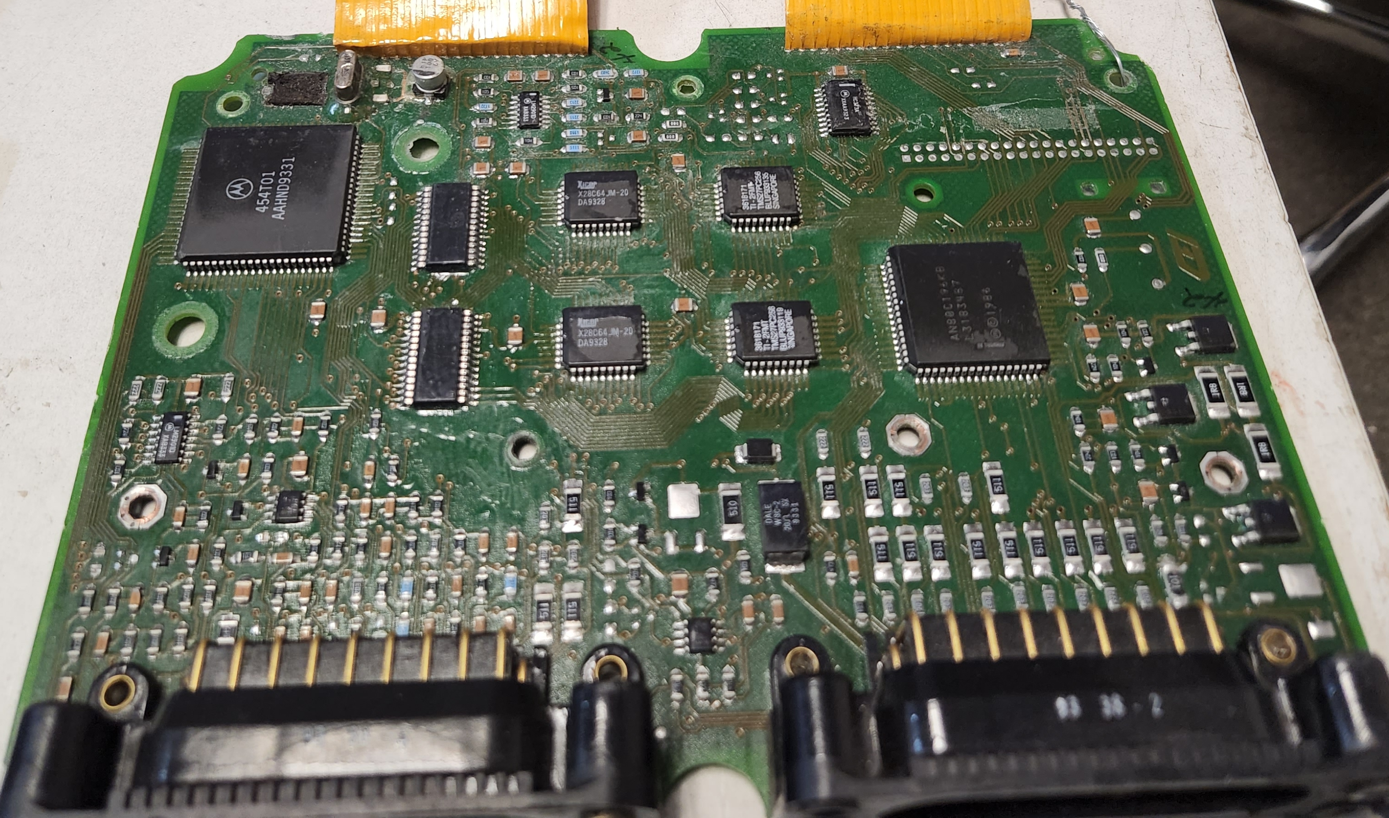
HIGH
LOW
-TMS27 or
-AT27C256R
HIGH
LOW
-X28C64 or
-AT28C64

